Project Planning Phase

**Project Planning Template (Product Backlog, Sprint Planning, Stories, Story points)**

|  |  |
| --- | --- |
| Date | 21 October 2023 |
| Team ID | NM2023TMID05035 |
| Project Name | Dissecting the digital landscape: A comprehensive analysis of social media |
| Maximum Marks | 8 Marks |

# Product Backlog, Sprint Schedule, and Estimation (4 Marks)

Use the below template to create product backlog and sprint schedule

|  |  |  |  |  |
| --- | --- | --- | --- | --- |
| **Sno** | **Sprint** | **Member Names** | **Description** | **Date** |
| **1** | **Sprint 1** | **Jayasri** | **Data Collection and Ingestion** | **Sep 20 - 2023** |
| **2** | **Sprint 2** | **Jayasri,Kalaiselvan** | **Data Processing and Analysis** | **Sep 22 - Sep 26,**  **2023** |
| **3** | **Sprint**  **3** | **Jasim ali,Kalaiselvan** | **User Interface Design and**  **Visualization** | **Sep 26 - Oct 1,**  **2023** |
| **4** | **Sprint 4** | **Jayasri,Kalaiselvan** | **Data Integration and Framework Modeling** | **Oct 1 - Oct 6, 2023** |
| **5** | **Sprint 5** | **Kalaiselvan** | **User Authentication and Security** | **Oct 8 - Oct 14,**  **2023** |
|  |  |  |  |  |
| **6** | **Sprint**  **6** | **Jasim ali, Kalaiselvan** | **Reporting and Dashboard**  **Development** | **Oct 15 - Oct 18,**  **2023** |
| **7** | **Sprint**  **7** | **Kalaiselvan,kalaiselvan** | **Testing and Quality Assurance** | **Oct 19 - Oct 24,**  **2023** |
| **8** | **Sprint 8** | **Jasim ali, Jayasri** | **Deployment and Release** | **Oct 25 - Oct 27,**  **2023** |

|  |  |  |  |  |  |  |
| --- | --- | --- | --- | --- | --- | --- |
| **Sprint** | **Functional Requirement (Epic)** | **User Story Number** | **User Story / Task** | **Story Points** | **Priority** | **Team Members** |
| **Sprint 1** | **Data Collection** | **US001** | **As a Marketing Manager, I want to access IBM Cognos Analytics to collect data for campaign analysis.** | **5** | **High** | **Jayasri**  **Jasim ali**  **Kalaiselvan k**  **Kalaiselvan M** |
|  | **Data Integration** | **US002** | **As a Data Analyst, I want to integrate data from various sources into IBM Db2.** | **8** | **High** | **Jasim ali**  **Jayasri** |
|  | **Data Security** | **US003** | **As an IT Specialist, I want to ensure secure**  **data access and encryption during integration.** | **5** | **High** | **Kalaiselvan K**  **Kalaiselvan M** |
| **Sprint 2** | **Data Transformation** | **US004** | **As a Data Analyst, I want to clean and transform data for accurate analysis.** | **8** | **High** | **Jasim ali**  **Jayasri** |
|  | **Data Analysis** | **US005** | **As a Data Analyst, I want to use IBM Cognos Analytics to analyze marketing campaign**  **data.** | **8** | **High** | **Jasim ali** |
|  | **Data Visualization** | **US006** | **As a Data Analyst, I want to create data**  **visualizations to represent campaign insights.** | **5** | **High** | **Jayasri** |
| **Sprint 3** | **Data Presentation** | **US007** | **As a Marketing Manager, I want to view dashboards with campaign insights and**  **trends.** | **3** | **High** | **Kalaiselvan k** |
|  | **Decision-Making** | **US008** | **As a Marketing Manager, I want to make data-**  **informed decisions for campaign optimization.** | **5** | **High** | **Kalaiselvan m** |
|  | **Compliance and Privacy** | **US009** | **As a Compliance Officer, I want to ensure GDPR compliance in data handling.** | **5** | **High** | **Jasim ali**  **Jayasri** |
| **Sprint 4** | **Budget Optimization** | **US010** | **As a Finance Team member, I want to use**  **data insights to optimize campaign budgets.** | **8** | **Medium** | **Kalaiselvan K**  **Kalaiselvan M** |
|  | **Customer Feedback Analysis** | **US011** | **As a Customer Support representative, I want**  **to analyze customer feedback data.** | **5** | **Medium** | **Kalaiselvan k** |
|  | **Real-Time Insights** | **US012** | **As a Marketing Manager, I want to access**  **real-time marketing campaign insights.** | **3** | **Medium** | **Kalaiselvan M** |
| **Sprint 5** | **Collaboration Tools Integration** | **US013** | **As a Project Manager, I want to integrate**  **collaboration tools for team communication.** | **3** | **Medium** | **Jasim Ali** |
|  | **Mobile Compatibility** | **US014** | **As a User, I want the application to be accessible on mobile devices for**  **convenience.** | **3** | **Medium** | **Jayasri** |
|  | **Data Backup and Recovery** | **US015** | **As an IT Specialist, I want to implement data**  **backup and recovery solutions.** | **5** | **Medium** | **Kalaiselvan**  **Kalaiselvan** |
| **Sprint 6** | **User Training** | **US016** | **As a Project Manager, I want to conduct user**  **training and provide resources.** | **3** | **Low** | **Jayasri** |
|  | **Performance Optimization** | **US017** | **As an IT Specialist, I want to optimize application performance for faster data**  **analysis.** | **5** | **Low** | **Kalaiselvan m** |

|  |  |  |  |  |  |  |
| --- | --- | --- | --- | --- | --- | --- |
|  | **Integration with Marketing Tools** | **US018** | **As a Marketing Manager, I want to integrate the application with marketing automation tools.** | **5** | **Low** | **Kalaiselvan** |
| **Sprint 7** | **Final Testing** | **US019** | **As a QA Specialist, I want to conduct comprehensive testing before deployment.** | **5** | **High** | **Kalaiselvan**  **Jasim ali** |
|  | **Deployment Planning** | **US020** | **As a Project Manager, I want a detailed deployment plan for a seamless rollout.** | 5 | High | Jayasri |
| **Sprint 8** | **Post-Deployment Review** | **US021** | **As a Project Manager, I want to review the**  **deployment's success and gather feedback.** | **3** | **High** | **Kalaiselvan** |
|  | **Documentation** | **US022** | **As a Technical Writer, I want to create system**  **documentation for reference.** | **5** | **High** | **Jasim ali** |
|  | **Project Closure** | **US023** | **As a Project Manager, I want to close the project and conduct a final assessment.** | **8** | **High** | **Kalaiselvan K**  **Kalaiselvan M** |

# Velocity:

Imagine we have a 10-day sprint duration, and the velocity of the team is 20 (points per sprint). Let’s calculate the team’s average velocity (AV) per iteration unit (story points per day)



# Burndown Chart:

A burn down chart is a graphical representation of work left to do versus time. It is often used in agile [software development](https://www.visual-paradigm.com/scrum/what-is-agile-software-development/) methodologies such as [Scrum](https://www.visual-paradigm.com/scrum/scrum-in-3-minutes/). However, burn down charts can be applied to any project containing measurable progress over time.

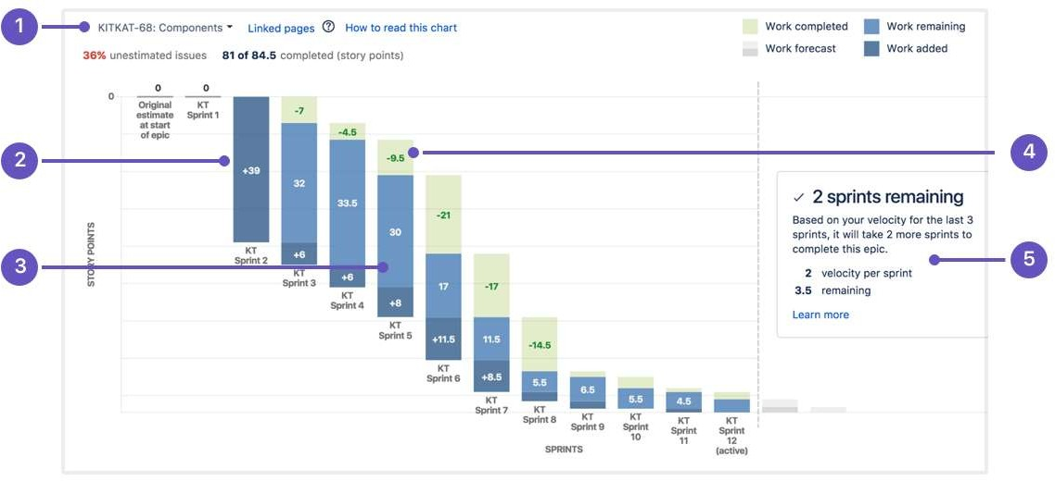

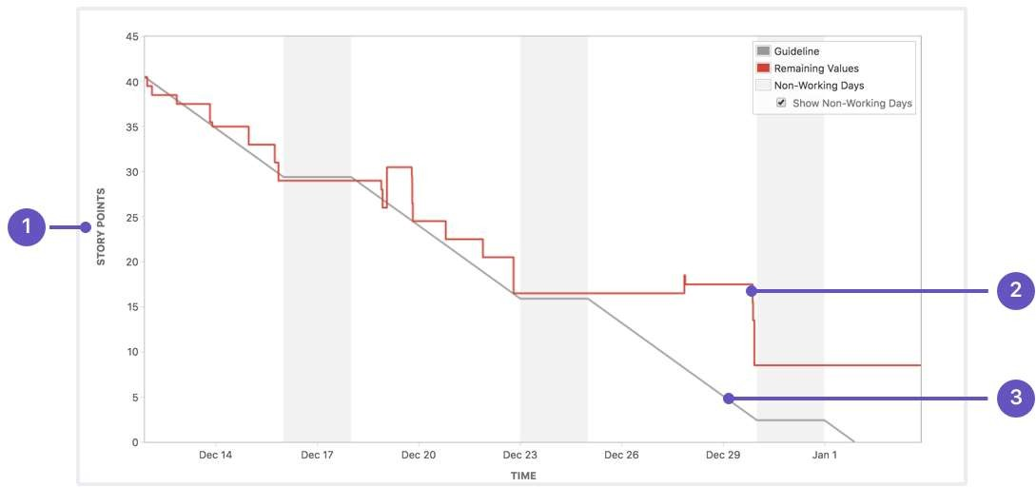

**OCT 27**

**OCT 24**

**OCT 20**

**OCT 12**

**OCT 5**

**SEP 25**

**SEP 22**